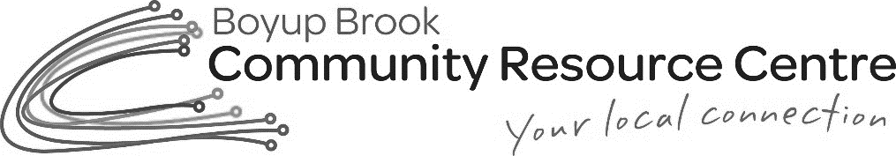

Boyup Brook Public Library Membership Form

Surname: _________________________ First Name: ______________________
Date of Birth: ___________________ Drivers License #: ____________________
Address: _____________________________________Postcode: _____________
Home Phone: ______________________ Mobile: __________________________
Email Address: __________________________ Postcode: __________________

Boyup Brook Public Library Information

· Library Opening times 9:00am to 4:00pm Monday-Friday
· No food or drink is to be consumed in the Library
· Cost price of items will be paid by patron if items are damaged or lost.
· All items are on loan for three weeks
· There is a maximum limit of 30 items to be borrowed at any one time.
· Extension of loan due dates can be arranged by contacting the Library
on 9765 1169 or email library@boyupbrook.org
· If you would like to borrow a book not in our collection, please complete a loan request form, available from the Library.

Office Use Only
Date Entered:______________ Membership No:___________________________ Pin No: _______

